IMPROVING FIBROMYALGIA/CHRONIC FATIGUE IN 30 DAYS
Fibromyalgia/Chronic Fatigue Relief within 30 Days,
Recovery Plan for Long-Term Health
IMPROVING FIBROMYALGIA/
CHRONIC FATIGUE
IN 30 DAYS
By Robert Redfern
©
2013
Naturally Healthy Publications All rights reserve
d
.
Naturally Healthy Publications
www.NaturallyHealthyPublications.co
m
About the Author
Robert Redfern – Your Personal Health Coach www.MyGoodHealthClub.com
Robert Redfern (born January 1946) has helped hundreds of thousands of people in over 24 countries through online health support websites, books, radio/TV interviews, and his nutritional discoveries. His new series of books brings this work together in an easy-to-read format that everyone can follow to help resolve their chronic health problem – once and for all.
Robert’s interest in health started when he and his wife Anne decided to take charge of their family’s health in the late 1980s. Up until 1986, Robert had not taken much notice of his health – in spite of Anne’s loving persuasion. It took the premature death of his parents, Alfred and Marjorie, who died in their sixties, to shock Robert into evaluating his priorities.
Robert and Anne looked at the whole field of health, available treatments and the
causes of health problems. They found, from doctors researching the causes of disease, that lifestyle and diet were the most important contributions to health. Robert and Anne changed their lifestyle and diet and, together with the use of HealthPoint™ acupressure, the improvement to their health was remarkable.
As well as good health, they feel and look younger and more energetic than all those years ago – before they started their plan. At the time of printing, Robert, aged 67, and Anne have every intention of continuing to be well and looking younger, using their unique understanding of Natural Health.
ROBERT REDFERN
YOUR PERSONAL HEALTH COACH
Tells you everything you need to know about:
Fibromyalgia/Chronic Fatigue
Improvement in 30 Days
The Causes
& The Recovery Plan
Published by
NATURALLY HEALTHY PUBLICATIONS
All rights reserved. No part of this book may be reproduced in any form, or by any means, without the written permission from the author.
Printed in the UK.
From the Publisher:
This book does not intend to diagnose disease nor provide medical advice. Its intention is solely to inform and educate the reader in changing to and living a healthy lifestyle.
Warning: Some information may be contrary to the opinion of your medical adviser; however, it is not contrary to the science of good health.

CONTENTS
What Is Fibromyalgia/Chronic Fatigue? 7
The Western Un-Natural Food Diet
Can I Reverse Fibromyalgia?
The Nutrients You Need
Why Doesn’t My Doctor Tell Me I Can Get Better?
The Fibromyalgia Rehabilitation Plan
1
. Clearing Inflammation, Energizing Your Cells, and Promoting Healing
2
. Taking the Missing Nutrients
. Immune Recovery and Strengthening
3
Optional Nutrients - but Suggested for the First 1 to 2 Months At Least
. Drinking Enough Water.
4
. Avoiding Eating Unnatural Junk Foods
5
6
. Eating Real Foods
. Walking and Moving Daily
7
. Breathing Properly
8
9
. Stimulating the Acupressure Points
10
. Getting Out into the Sun As Much As Possible
More About Clearing Inflammation, Energizing Your Cells, and Promoting Healing
More About Missing Nutrients
More About Immune Strengthening Formulations
More About Optional Nutrients
More About Acupressure
In Conclusion:
Sample Daily Fibromyalgia Rehabilitation Plan
My Good Health Club
11
12
13
14
15
16
16
17
18
18
18
19
23
25
26
26
27
30
32
33
36
37
38
40
COMMITMENT PLAN

YOUR ACTION PLAN TO COMMIT TO BETTER HEALTH
TODAY I DID THIS Signed Date
I Committed To regaining and maintaining my health for the rest of my life
I Committed
To drinking 8-10 glasses of water a day
I Committed
To getting out in the sun for 20 minutes a day (except when contraindicated)
I Read
Robert’s Fibromyalgia/Chronic Fatigue Recovery Book
I Ordered
The necessary supplements to facilitate my plan and my healing
I Planned
My Daily Menu with
ReallyHealthyFoods.co
m
I Started
My breathing exercises
I Started
Massaging the acupressure points
I Reread
Robert’s Fibromyalgia/Chronic Fatigue Recovery Book
I Reviewed
The necessary supplements to facilitate my plan and my healing
I Reviewed
My water intake
I Reviewed
My menu
I Reviewed
My breathing exercises
I Reviewed
My life-giving sun exposure (except when contraindicated)
I Reviewed
Massaging the acupressure points
I Recommitted
To regaining and maintaining my health for the rest of my life
I Recommitted
To Robert’s Fibromyalgia/Chronic Fatigue Recovery Book
I Recommitted
The necessary supplements to facilitate my plan and my healing
I Recommitted
To my water intake
I Recommitted
To following my menu
I Recommitted
To doing my breathing exercises
I Recommitted
To life-giving sun exposure (except when contraindicated)
I Recommitted
To massaging the acupressure points

What Is Fibromyalgia/Chronic Fatigue?
What do fibromyalgia and chronic fatigue have in common?
There are several connections between the two conditions. Perhaps the biggest connection is the lack of belief that these conditions even exist. This lack of belief leads to a lack of support and empathy for the sufferer, which can sometimes exacerbate their illness even more. It is estimated that millions of people suffer with these conditions; however, exact numbers are difficult to come up with due to the skepticism of many in the medical community.
Another similarity these conditions have in common? Anyone with chronic fatigue or fibromyalgia will talk about how they feel tired and just plain bad most of the time.
Fibromyalgia and chronic fatigue display exactly the same symptoms and respond to the same recovery plan. For the purposes of this book, we will refer to both as fibromyalgia.
Fibromyalgia is an autoimmune syndrome (FMS) characterized by sleeplessness and pain in the muscles, tendons, and ligaments. It is thought of as a rheumatic disease, meaning inflammatory proteins called cytokines may be initiating and/or perpetuating inflammation.
Oxidative stress (an overload of health-damaging free radicals in the body) appears to be higher in fibromyalgia patients.

I suffered from fibromyalgia, collagenous colitis, and migraines. After starting your plan, the migraines stopped in about one week migraines and have not returned. My muscle and joint pain was also greatly relieved. A colonoscopy was negative for collagenous colitis! My quality of life greatly improved! I no longer suffer from migraines, sinus infections, depression, or severe pain.
Z.T. USA

Who Gets Fibromyalgia?
- Women endure fibromyalgia ten times more than men.
- Age is also a risk factor as the incidence of fibromyalgia goes up with age.
- Fibromyalgia occurs most often during middle-age.
Fibromyalgia Signs and Symptoms
Difficulty sleeping and fatigue afflict almost everyone with fibromyalgia. People with this syndrome also frequently experience pain throughout the entire body.
Other complications include:
- Trouble concentrating
- Sensitivity to environmental triggers
- Burning/tingling in areas of the mouth
- Paresthesia (feeling of tickling, tingling, burning, pricking, or numbness of the skin with no obvious long-term consequences)
It is quite common for other conditions to affect those with fibromyalgia, like:
- Candida
- Weight issues
- Irritable bowel syndrome (IBS)
- Mood disorders
- Headaches
I suffered a neck injury from a car accident, then Fibromyalgia and back pain, then a shoulder injury. I got the HealthPoint electronic acupuncture kit. I had used it for three months and then the results began to be felt. It was amazing. I used it many times a day until the results came. I was healed. That’s all I can say. I never use it much anymore, but I have it near if I do need it. I can do most of the things I did before the accident.
L.B. Canada
Fibromyalgia Causes
Fibromyalgia can be brought on by a number of factors, including:
- Injury
- Giving birth
- Infections that stem from a virus, parasite, or one that is sensitive to antibiotics
- Environmental toxins
- Hormonal imbalance
- Prolonged stress
- Autoimmune disorders
- Conditions or scenarios that interrupt normal sleep patterns
These factors can take hold and affect a person’s health due to chronic inflammation in the body and an already compromised immune system that may stem from:
- Consumption of foods containing excitotoxins (MSG, aspartame, and other food additives that stimulate nerves and increase pain sensitivity)
- Preservatives
- Gluten and other proteins
- Sugar
- Peanuts
It is also advisable to avoid drinking alcohol, using tobacco products, and consuming meat (especially red meat), dairy products, sugar, starchy carbohydrates, artificial sweeteners, fried foods, and junk fat.
A diet lacking in enzymes, nutrients, and healthy foods may contribute to fibromyalgia.
I would like to take this opportunity of saying how much I find the Healthpoint acupressure device very helpful. I have had arthritis from the age of 12 and now for the past 4 years have Fibromyalgia but with your treatment and supplements still keep active at age 72 and manage a large house and 1 acre of garden very well by spacing out my energy sensibly.
Pamela A. UK
Fibromyalgia Treatment Plan

Tender points, not to be confused with trigger points, are areas in the body where sensitivity can be measured and fibromyalgia diagnosed.

When diagnosed with fibromyalgia, it is imperative to make the following a part of your treatment plan:
- Move on a regular basis; yoga or walking is ideal.
- Get coaching for emotional reassurance.
- Utilize electro-acupressure.
- Seek out physical therapy.
- Get a good night’s sleep.
Fibromyalgia Sleep Tips
- Relax in a tub before bedtime.
- Keep your bedroom at a comfortable temperature, preferably on the cooler side.
- Invest in earplugs if your partner snores.
- Drink no fluids before bed.
- Train your bladder to sleep through the night, i.e. try not to give in and get up every time you feel the urge to urinate.
- Move the alarm clock out of your line of vision.
- Don't go to bed hungry.
- Stick to a rigid sleep schedule: Go to bed and get up at the same time every day!
- Remember, resolving a sleep disorder is
crucial to recovery.
Keep in mind that when the immune system is compromised, the body is more susceptible to infection.

The Western Un-Natural Food Diet
In addition to non-adherence to the specific food guidelines laid out in this book, a diet which will definitely hinder one’s recovery from fibromyalgia is the Western Un-Natural Food Diet.
Nothing affects us more than what we choose to eat at least three to four times a day, every day.

Most of us lack the essential nutrients in our diet needed for good health, perpetuating inflammation. This absence of nutrients combined with one or several other unhealthy lifestyle factors can perpetuate fibromyalgia.
The “Balanced Western Diet” (now better described as the Western Un-Natural Food Diet) is the number one disease-promoting and inflammation-producing diet in modern society. It is consumed more and more on a daily basis.
This highly inflammatory diet is made up of sugary foods in the form of breads, pastas, cereals, and potatoes. The Western Un-Natural Food Diet is far too high in unhealthy fats and lacks the antioxidants and phytochemicals that are crucial for eliminating free radicals. This all-too-common diet is lacking in high fibre foods and the foods that provide essential nutrients necessary to find relief from fibromyalgia.
These missing foods include:
Arginine in the Diet
- Vegetables
- Dark-skinned fruits It is widely known that foods high in arginine slow recovery
- Nuts can trigger the latent virus that is responsible
- Seeds for continuing fibromyalgia issues.
- temporarily contraindicated) If you're suffering from a fibromyalgia/chronic fatigue flare-up, it is worthwhile to cut out any
Beans (except when
arginine supplements you may be taking. You must also avoid high-arginine foods like:
- Almonds • Peanuts
- Brown rice • Sesame seeds
- Brussels sprouts • Soybeans
- Caffeine •Split peas
- Chocolate* Sunflower seeds
- Corn • Walnuts
- Millet • Wheat germ
- Oatmeal • Whole-wheat
- Onions bread
- Pecans
Adding a high dose of L-lysine capsules first thing in the morning can help to bring this issue under control.
Can I Reverse Fibromyalgia?
I do not believe it is appropriate to use the term “cure” for fibromyalgia since most cases are brought on (or made worse) by lifestyle choices.
Cure is a medical term, and medicine does not offer any cures. However, everything has a cause. Take away the cause, apply the science of a non-inflammatory lifestyle, and your body will be able to repair itself with a little bit of help. Support tissue regeneration with a healthy lifestyle and the proper nutrients, and in the majority of cases you can become healthy again. If you call that a cure, that’s up to you. I prefer to call it living a sensible, healthy lifestyle.
Remember, these conditions are inflammatory in nature and, therefore, will benefit from an anti-inflammatory approach. By hydrating the body with pure, clean water {6-8 x 500 ml (16 oz.) glasses a day} and replenishing it with the proper nutrients and antioxidants in the form of vitamins, minerals, essential fatty acids, healthy carbohydrates, and amino acids, the repair and healing of the body can start to take place.
Nutritional therapy supports healing.
The initial detox can be uncomfortable but only temporarily.
Eating right can minimize the effects.
. . . regenerate with healthy lifestyle and nutrients . . .
The Nutrients You Need
Studies show the following nutrients will help prevent or control fibromyalgia in most people:
- Sodium Thiocyanate and Sodium
Hypothiocyanite - To clear any infection that may reside in the cells.
- SerraEnzyme Serrapeptase, Curcuminx4000,
Ecklonia Cava (Seanol), and Vitamin D3 - To support inflammation and health recovery.
- Glyconutrients and L-Glutamine - To promote healthy sleep and restore the digestive tract.
- Nascent Iodine - Essential for balanced immune health.
- 90 Vitamins/Minerals - Full spectrum
multivitamin/mineral, which you should already be taking daily.
- Probiotics (Friendly Bacteria) - To recover
gut-friendly flora, taken therapeutically and then for maintenance.
- Ubiquinol (8 times more effective than
CoQ10) - Powerhouse antioxidant essential for all cell energy.
- D-Ribose Plus™ - Essential to restore cell energy as shown in studies.
- L-Tryptophan, L-Theanine, Vitamin B6, and Vitamin B3 - To support a relaxed system with healthy sleep patterns and to reduce anxiety.
Why Doesn’t My Doctor Tell Me I Can Get Better?
The Non-Inflammatory Lifestyle Program can help you get better! Your doctor is obliged to conform to the drug model that is designed to maintain the monopoly that the pharmaceutical industry, the GMC in the UK and the AMA in the USA, have over all things connected with the health of individuals.
These organizations make profits by caring for sick people and do not have a business model that caters to real healthcare and recovery. They pursue a patented drug model where they can charge exorbitant prices for a lifetime of drugs that, at best, help individuals feel better and, at worse, speed up their death.
These industries are not designed to get anyone healthy, ever!
In the USA, they are shielded by the FDA and in the UK by the MHRA. The political parties and the most powerful politicians all receive money from these organizations and are responsible for making the laws that perpetuate this disease management monopoly.
When carefully followed, the Non-Inflammatory Lifestyle Program will show results within 30 days.
I would like to take this opportunity of
saying how much I find the Healthpoint
acupressure device very helpful.
I have been taking your things for about 6
months now and find it helps immensely
with fibromyalgia symptoms. We started
on it to help my son who suffers asthma
and had inhaled a lot of paint/lacquer
fumes when he was spraying one of his
guitars (he's a guitar repairer/luthier)
and the serrapeptase, I'm sure was a
lifesaver. Thank you again for your
wonderful product, I have told quite a
few people about it, as I think it's just
great.
Cheers.
Lenice, Australia
The Fibromyalgia Rehabilitation Plan
Your 10 Steps to a Healthy Future
The following protocol works for any type of fibromyalgia condition, to some extent.
Clearing inflammation, energizing

6

7

8

9
10

1

2

3

4

5
your cells, and promoting healing. ^{Eating real foods.}
Strengthening your immune
system.Walking and moving daily.
Taking nutrients missing from Breathing properly. food in supplement form.
Drinking enough water.Stimulating acupressure
points.
Avoiding unnatural/junk Getting out into the sun as foods.much as possible.
It is almost unheard of for a person applying a good percentage of these lifestyle changes to their daily life to not clear their fibromyalgia symptoms to some extent, and in many cases completely.
For details of the following suggested formulas, turn to page 27.
1. Clearing Inflammation and Promoting Healing
Basic Plan • 1st Line Immune Support: To clear any infection that may reside in the cells. Take 1 kit daily for 3 days
(total of 3). Always take at least 90 minutes after food and 90 minutes before food. 3 kits should be taken as a minimum; in serious conditions, 10 kits are better if finances allow.
- Serranol: To support inflammation and health recovery; SerraEnzyme Serrapeptase, Curcuminx4000, Ecklonia Cava (Seanol), and Vitamin D3. Take 2 capsules x 3 times per day, 30 minutes before eating a meal with water; reduce to 1 x 3 after a good relief.
- Nascent Iodine: Helps balance hormones and metabolism as per the instructions. Take 4 x 4 drops per day in water. Build over 2 weeks up to 10 x 4 until well and then slowly reduce back to 4 x 4.
2. Taking the Missing Nutrients
Advanced Plan
- 1st Line Immune Support:To clear any infection that may reside in the cells. Take 1 kit daily for 3 days
(total of 3). Always take at least 90 minutes after food and 90 minutes before food. 3 kits should be taken as a minimum; in serious conditions, 10 kits are better if finances allow.
- Serranol: To support inflammation and health recovery; SerraEnzyme Serrapeptase, Curcuminx4000, Ecklonia Cava (Seanol), and Vitamin D3. 2 capsules x 3 times per day, 30 minutes before eating a meal with water; reduce to 1 x 3 after a good relief.
- Nascent Iodine: Helps balance hormones and metabolism as per the instructions. Take 4 x 4 drops per day in water. Build over 2 weeks up to 10 x 4 until well and then slowly reduce back to 4 x 4. 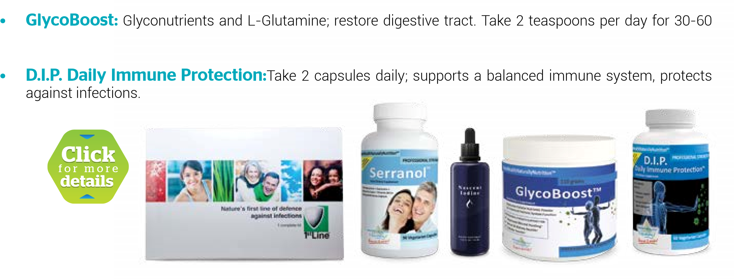days.

3. Immune Recovery and Strengthening
Ultimate Plan • 1st Line Immune Support: To clear any infection that may reside in the cells. Take 1 kit daily for 3 days
(total of 3). Always take at least 90 minutes after food and 90 minutes before food. 3 kits should be taken as a minimum; in serious conditions, 10 kits are better if finances allow.
- Serranol: To support inflammation and health recovery; SerraEnzyme Serrapeptase, Curcuminx4000, Ecklonia Cava (Seanol), and Vitamin D3. 2 capsules x 3 times per day, 30 minutes before eating a meal with water; reduce to 1 x 3 after a good relief.
- Nascent Iodine: Helps balance hormones and metabolism as per the instructions. Take 4 x 4 drops per day in water. Build over 2 weeks up to 10 x 4 until well and then slowly reduce back to 4 x 4. • GlycoBoost: Glyconutrients and L-Glutamine; restore digestive tract. Take 2 teaspoons per day for 30-60 days.
- D.I.P. Daily Immune Protection: Take 2 capsules daily; supports a balanced immune system, protects against infections.
- Prescript Assist 29 Super Strain Probiotic: You likely need to take this therapeutically and then for maintenance.

Optional Nutrients - but Suggested for the First 1 to 2 Months At Least
- Ubiquinol (8 times more effective than CoQ10) - A powerhouse antioxidant that is essential for all cell energy; 2 x 2 times per day with food for 1 month (then 1 x 2 forever).
- D-Ribose Plus™: Essential to restore cell energy. 5 teaspoons x 3 drops per day in water. • RelaxWell™ - To support a relaxed system with healthy sleep patterns and to reduce anxiety. Take 1 capsule, 3 times a day.

- Drinking Enough Water.
Drink 6-8 glasses of distilled or RO filtered water per day, with a large pinch of bicarbonate of soda (baking soda) for internal organ support.
- Avoiding Eating Unnatural Junk Foods.
Until completely recovered, stop eating all starchy carbohydrates (breads, pastry, cookies, breakfast cereals, potatoes, and pasta), processed foods, and milk products.
Note: Do not eat potatoes, parsnips, turnips, and rice (except for a small amount of wild or brown rice and yams/sweet potatoes).

6. Eating Real Foods
**Include some of the following foods every 2 hours for the first few months:
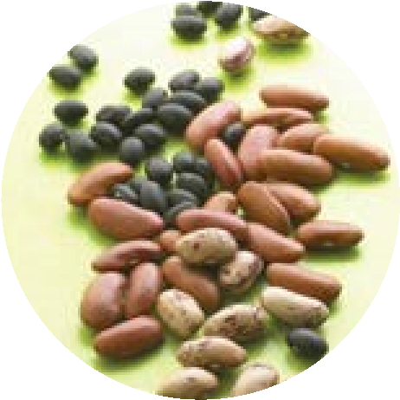
Eat 9-14 portions of fresh or frozen veggies daily (in soups, juiced, stirfried, steamed, etc.); 50% raw juiced (use the pulp in soups) and organic if possible. Blended makes for better digestion.
Eat 5 portions of antioxidant-rich, dark-skinned fruits (blueberries, cherries, red grapes, etc.) daily.
Avocados are the all-time super food with nearly a full spectrum of nutrients. If they are available where you live, make sure you have at least 2 per day for good health recovery. All fibromyalgia issues (as well as cancer and diabetes) are helped by these.
Eat 5 portions of beans, nuts, and seeds (soaked and mashed for the nuts and seeds).
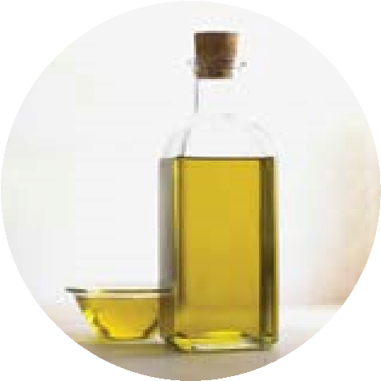
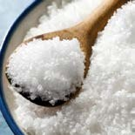
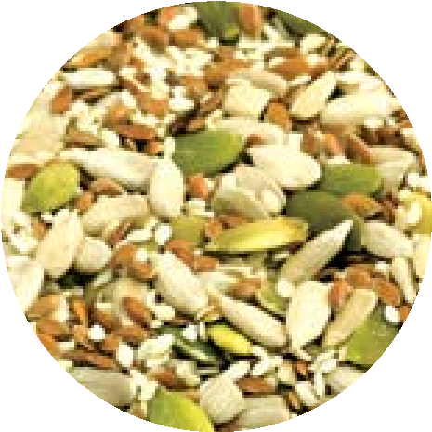
If you want to eat meat, then choose pasture-fed meats or chicken and eat only a small amount weekly. Grass-fed is healthier than grain or corn-fed animals.
If you eat fish, then eat at least 3-4 portions per week of oily fish and vary it by choosing fish such as salmon, sardines, mackerel, etc. Even canned fish is very nutritious, and wild caught fish is best.
Include Hemp, Omega 3, or Krill oil and other healthy oils like Olive oil and Coconut oil.
As healthy alternatives to carbs, consider Quinoa, Chia Seeds, Amaranth, Buckwheat, and Millet Seeds. Cous Cous can be used, except for those who are allergic to gluten proteins (celiacs, etc.).
Take 3-5 (depending upon your body mass and the heat) teaspoons of Sea or Rock Salt daily in food or a little water. Sea or Rock Salt does not contain the critical mineral iodine, so add Nascent Iodine to your daily dose.
Which Vegetables to Eat
•
Artichoke
•
Asian Vegetables Sprouts (Wheat, Barley,
Alfalfa, etc.)
•
Asparagus
•
Avocado
•
Broad Beans
•
Cabbage (various types)
•
Dandelion Leaves
•
Dried Peas
•
Fennel
•
Garden Peas
•
Garlic
•
Kale
•
Lettuce (Kos and various types)
•
Mangetout Peas
•
Mushrooms
•
Petit Pois Peas
•
Runner Beans
•
Seaweed all types (Kelp, Wakame, Noni, etc.)
•
Sugar Snap Peas
•
Beetroot
•
Broccoli
•
Brussels Sprouts
•
Capsicum
•
Carrots
•
Cauliflower
•
Celeriac
•
Choko
•
Cucumber
•
Eggplant (Aubergine)
•
Kale
•
Kohlrabi
•
Kumara
•
Okra
•
Onions (red and white)
•
Radishes
•
Silver Beet
•
Spinach
•
Squash
•
Zucchini (Courgettes)
Note: Not all vegetables listed are available in every country.
Which Fruits to Eat
•
Apple
•
Apricot
•
Avocado
•
Blackberries
•
Blackcurrants
•
Bilberries
•
Blueberries
•
Cherries
•
Cherimoya
•
Dates
•
Damsons
•
Durian
•
Figs
•
Gooseberries
•
Grapes
•
Grapefruit
•
Kiwi fruit
•
Limes
•
Lychees
•
Mango
•
Nectarine
•
Orange
•
Pear
•
Plum/Prune (dried plum)
•
Pineapple
•
Pomegranate
•
Raspberries
•
Western raspberry (blackcap)
•
Rambutan
•
Salal berry
•
Satsuma
•
Strawberries
•
Tangerine
Note: Not all fruits listed are available in every country.

The Garden of Eden Pyramid
Vegetables (not root): 8-12 portions per day At least 1/2 should be raw, as in salad, etc.
Nuts Seeds 2-3
Fruits 2-3
Oils - Hemp, Fish, Olive
Beans Pulses 2-3
Organic is
BEST!
Fish Meats
(
)
Naturally Reared

7. Walking and Moving Daily
Contrary to the opinion of fitness fanatics, there are two simple ways to get your body working better and stronger. And no, they do not include swimming and cycling, although you can add these later if you want to.
One of the two simple ways to exercise is to build up to walking 3-5 miles per day, in a fast, purposely strong way with as long a stride as you can. Keep your hands moving from chest level to belt level as you move with each stride.
Hold your head high.
Focus your eyes 15
feet to 20 feet in front
of you.
Keep your chin
parallel to the
ground.
Move shoulders
naturally and
freely.
Gently tighten
stomach muscles.
Tuck your pelvis
under your torso.
Position your feet
parallel to each other,
if comfortable, and
shoulder-width apart.
Swing your arms in a
natural motion while
walking briskly.
Use weights or wrist weights as you improve.
If this is difficult for you at the start, and your lungs are weak, then lie down to exercise to make it easier.
Lie down in a comfortable place. On your bed (if it’s firm enough) when you first wake up is a great time and place for this. Bring a knee up to your chest as high as you can get it and then alternate with the other knee. Do as many of these as you can while keeping count. Do this every day and set yourself targets to increase the speed and the number as the weeks go by. You should be doing enough to make your lungs and heart beat faster. At the same time, as you improve your count on your back you need to be starting your walking and building this up.
The second great exercise for strengthening your lungs is to build up slowly where you can exercise at maximum rate for 2 minutes, 6 times per day. It does not matter what exercise you do, e.g. skipping, star jumps, running on the spot; just about anything, as long as your heart and lungs are working at maximum capacity. By working at maximum rate, your muscles connected with your heart and lungs will get stronger, and health will balance perfectly.
Movement is a vital part of your recovery plan.
We all know how beneficial exercise is; however, when you are in chronic pain, exercise is probably the last thing you want to do. As inflammation subsides and the body strengthens, gentle exercise can be incorporated into the treatment plan.

8. Breathing Properly
It is critical to breathe properly for a healthy body. Oxygen is the prime source of health.
There are two ways to breathe:
- The first way is an anxious breath in the chest.
- The second way is a relaxed breath in the diaphragm, or more precisely, in the tummy area.
The first breath in the chest is part of the stress response and involves hormones such as cortisol. This type of breathing should last no longer than it takes to deal with a problem in life, and then another hormone kicks in to create relaxed breathing. If this stress type of breathing becomes chronic or habitual, then the cortisol and retained carbon dioxide become part of the problem, and the body’s natural healthy systems cannot function properly. It also weakens the immune system and opens you up to infections, which is the last thing you need with fibromyalgia.
Your goal is to relearn relaxed, healthy breathing, where you clear cortisol and carbon dioxide. Too much carbon dioxide in your bloodstream destroys something called hemoglobin, which is the blood’s method of carrying oxygen around the body. So it’s critical to be able to breathe in a relaxed way from the diaphragm.
HOW TO BREATHE PROPERLY
The simple way to learn is to lie on your back in a firm bed or on the floor on a blanket or mat. Put a bit of weight over your belly button, such as a heavy book. Take a breath into your nose so that the book rises as you fill your diaphragm (tummy) with air. Hold the breath in your tummy for the count of 4 and then breathe out through your nose and feel your tummy deflating. Let go of any tension you may have with the out-breath. Then repeat. Your upper chest should not move at all, which shows you are relaxed and not stress breathing.
Practice over and again while lying down, and once you have really got the long, slow rhythm of relaxed breathing, then try it standing up. You may feel dizzy to begin with getting all this fresh oxygen, but you must practice this every spare minute you have. You can access more resources on breathing lessons here.

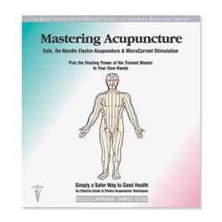
9. Stimulating the Acupressure Points
Another part of your recovery plan is to stimulate acupressure points connected to your health recovery system. There are various points that you can massage gently with your finger or stimulate with an electronic stimulator that mimics the action of acupuncture. The recommended device is HealthPoint™, and you can read more about this on page 36.

10. Getting Out into the Sun as Much As Possible
A critical vitamin for a healthy body is Vitamin D3. There is a large dose of this in the important supplement I recommend on page 28, but it is still essential to still get some Vitamin D from the sun.
The sun is the bringer of all life, and a silly myth has developed that the sun is our enemy and we should keep out of it, or worse still, put some toxic chemicals all over us so we can go out in it.
I am not saying that we can go out on a really hot sunny day and lie in the sun for 6 hours for the first time. We are supposed to build the skin’s tolerance to the sun over many weeks in the spring to stimulate protection from it, so that by the time the hot summer sun comes along we can tolerate much more.
Recommendations:
- Get as much skin exposed to the sun as you can every day,
e.g. on your daily walk.
- Build up slowly from the spring to summer time.
- Try not to stay out in the middle of the day without covering up, and cover up rather than use a barrier cream.
- If you do use a sun cream, get an organic one rather than chemical ones with well-known names.
- Remember, the sun is your friend, and as with friends,try not to get too much in one go!

More About Clearing Inflammation and Promoting Healing

1st Line (Thiocyanate) Immune System Support Kit
1st Line is a new all-natural product to fight against many types of infections, including viruses. It is a patented formula by a British Chemist containing Thiocyanate Ions. When added to water, 1st Line provides a drink, which forms the same molecules that make up our body's first line of defence against all types of bacteria, yeast, fungi, flu, germs, and viruses.
1st Line offers the aggressive attack to these unwanted infections without doing harm to healthy bacteria in the body, a common side-effect when using antibiotic drugs. 1st line is safe and easy to use.
Ingredients:
Sodium Thiocyanate - 100ppm
Sodium Hypothiocyanite - 60ppm
Dosage:
Take 1 kit daily for 3 days (total of 3).
Always take at least 90 minutes
before and after food.

Super Nutrient Serranol™
Super Nutrient Serranol™ offers professional strength support for healthy joints, cells, heart, blood flow, circulation, and cholesterol with ingredients like:
- Serrapeptidase (technically Serriatia Peptidase) is a multi-functional proteolytic enzyme that dissolves nonliving tissues, such as scarring, fibrin, plaque, blood clots, cysts, and inflammation in all forms – without harming living tissue. Serrapeptidase helps promote better wellbeing for your inflammatory system and supports your whole body, not only the lungs but also arteries, digestive tract, colon, joints, and anywhere blockages/ inflammation needs resolving.
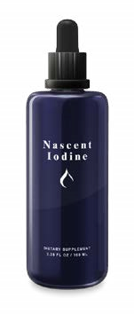
- Curcumin (CurcuminX4000) is one of the best

Nascent Iodine
natural anti-inflammatory herbs to stimulate glutathione to protect cells and tissue from inflammation and help modulate the immune system. Curcumin has also been studied for its anti-bacterial, anti-viral, and anti-fungal properties.
- Ecklonia Cava (Seanol®) – For centuries, people throughout Asia have consumed Ecklonia Cava Extract, a species of edible brown algae. Harvested from the coastal waters off Japan, Korea, and China, all studies indicate ECE offers outstanding health benefits.
- Vitamin D3 is critical to keep your immune system strong. The cells that make up the immune system contain vitamin D3 receptors. If there is an insufficient amount of vitamin D3 present to bind receptors, immune cells become weak and cannot protect the body from infections. Vitamin D3 deficiency is increasingly common in people of all ages because we spend less time outdoors in the sun, but this vital vitamin cannot be stored in the body. So replenishment through daily supplementation is vital to immune health.
Ingredients:
SerraEnzyme Serrapeptase® 80,000iu
Curcumin X4000 250mg
Ecklonia Cava Extract (Seanol®) 50mg
Vitamin D3 1000iu
Dosage:
2
capsules x 3 times per day, 30 minutes
before eating a meal with water; reduce
to 1 x 3 after a good relief.
Ingredients:
Iodine (in its atomic form) - 400 µg
Dosage:
Take 4 x 4 drops per day in water. Build
over 2 weeks up to 10 x 4 until well and
then slowly reduce back to 4 x 4.
Nascent Iodine is totally different from the typical iodine in its denser state sold as an antiseptic, or as iodine tri-chloride (claiming to be atomized), or as added to potassium iodide to make it soluble in liquid. Nascent Iodine is consumable iodine in its atomic form rather than its molecular form. It can provide benefits in thyroid and immune support, detoxification, metabolism, improved energy, and more.

More About Missing Nutrients

GlycoBoost™ Nutrient Formula
GlycoBoost™ is a potent and concentrated formula brimming with a full range of polysaccharides, natural plant sugars that store energy within your cells and release it as you need it. GlycoBoost is for the whole family, from children to grandparents and everybody in between. GlycoBoost can even benefit your pets.
GlycoBoost is designed to improve:
- Joint health and mobility
- Mood
- Cognitive senses
- •
•

Daily Immune Formulation (D.I.P.)
An alternative way to help keep infections away is to take a formulation designed to keep your immune system in balance. This formulation does not kill an existing infection but does help to prevent a new infection and allergen responses.
EpiCor® is a powerful antioxidant with an ORAC (Oxygen Radical Absorption Capacity) value of 52,500/100g, so it has huge health benefits as a free radical scavenger. Supported by years of research and development, EpiCor® is a unique product and is a valuable supplement for your immune health.
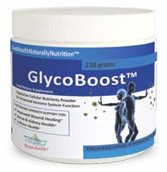
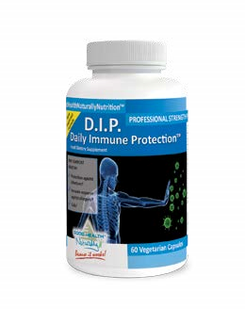
ExSelen® – Selenium is an essential trace mineral that the human body is dependent on, but can’t produce on its own. Selenium must be ingested through foods in our diet or by supplementation. ExSelen® is a highly bio-available organic selenium that guarantees consistently high levels of selenomethionine – the preferred form for efficient absorption by the body. This high quality raw material is backed by 15 years of research and by 60 years of proprietary fermentation technology. It is also a natural antioxidant that helps protect healthy cells from free radical damage and helps balance immune functions. Selenium supports the body’s normal inflammatory response in the lungs and may protect breast, prostate, and thyroid health.
•
Sleep
•
Skin
•
Memory
Digestion
Muscle movement
Chemotherapy side effects
Ingredients:
Proprietary Blend - 3.56g
L-Glutamine Powder
Aloe Vera Whole Leaf Powder Extract
Dosage:
Take 2 teaspoons per day for 30-60 days.
Vitamin D3
is critical to keeping your immune system
strong. The cells that make up the immune system contain
vitamin D3 receptors. If there is an insufficient amount of
vitamin D3 present to bind receptors, immune cells become
weak and cannot protect the body from infections. Vitamin D3
deficiency is quite common in individuals because it cannot
be stored in the body, making replenishment through daily
supplementation vital to immune health.
Ingredients:
Epicor® 500mg
ExSelen® selenomethionine 100mcg
Vitamin D3 1000iu
Formulated with other powerful ingredients like:
Vitamin C (from Ascorbic Acid) 120 mg
Zinc Glycinate Chelate 20% 5 mg
Dimethylglycine HCL 250 mg
Elderberry Fruit Extract 4:1 200 mg
Larch Arabinogalactan Powder 200 mg
Immune Assist - Micron Powder 80 mg
Beta Glucan 1,3 (Glucan 85%) 60 mg
Dosage:
Take 2 capsules per day.

More About Immune Strengthening Formulations

Prescript-Assist® (P-A)
Prescript-Assist® (P-A) is a 3rd-generation combination of 29 probiotic microflora “Soil-Based-Organisms
(SBOs)” uniquely combined with a humic/ fulvic acid prebiotic that enhances SBO proliferation. Prescript-Assist’s® microflora are Class-1 micro ecological units that are typical of those progressively found resident along the
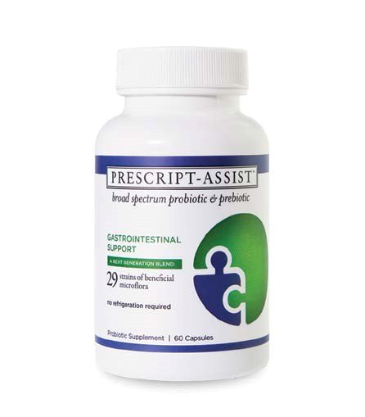
healthy human GI tract.
Ingredients:
Proprietary blend of Leonardite
Class I (beneficial microorganisms):
Anthrobacter agilis, Anthrobacter
citreus, Anthrobacter globiformis,
Anthrobacter luteus, Anthrobacter
simplex, Acinetobacter calcoaceticus,
Azotobacter chroococcum,
Azotobacter paspali, Azospirillum
brasiliense, Azospirillum lipoferum,
Bacillus brevis, Bacillus marcerans,
Bacillus pumilis, Bacillus polymyxa,
Bacillus subtilis, Bacteroides
lipolyticum, Bacteriodes
succinogenes, Brevibacterium
lipolyticum, Brevibacterium
stationis, Kurtha zopfil, Myrothecium
verrucaria, Pseudomonas calcis,
Pseudomonas dentrificans,
Pseudomonas flourescens,
Pseudomonas glathei, Phanerochaete
chrysosporium, Streptomyces
fradiae, Streptomyces celluslosae,
Streptomyces griseoflavus
Dosage:
Take 2 capsules per day for the first
30
days, followed by 1 to 2 capsules
per week thereafter. A full 30 day cycle
of 2 capsules per day should be used
to reconstitute beneficial gut flora
following any antibiotic regimen.

Active Life 90
Active Life 90 Powerful Liquid Vitamins & Minerals is a liquid formula to ensure you get all the essential vitamins and minerals needed by your body. This single liquid supplement allows for maximum absorption and utilization of the body - 300% more absorbent than tablets!
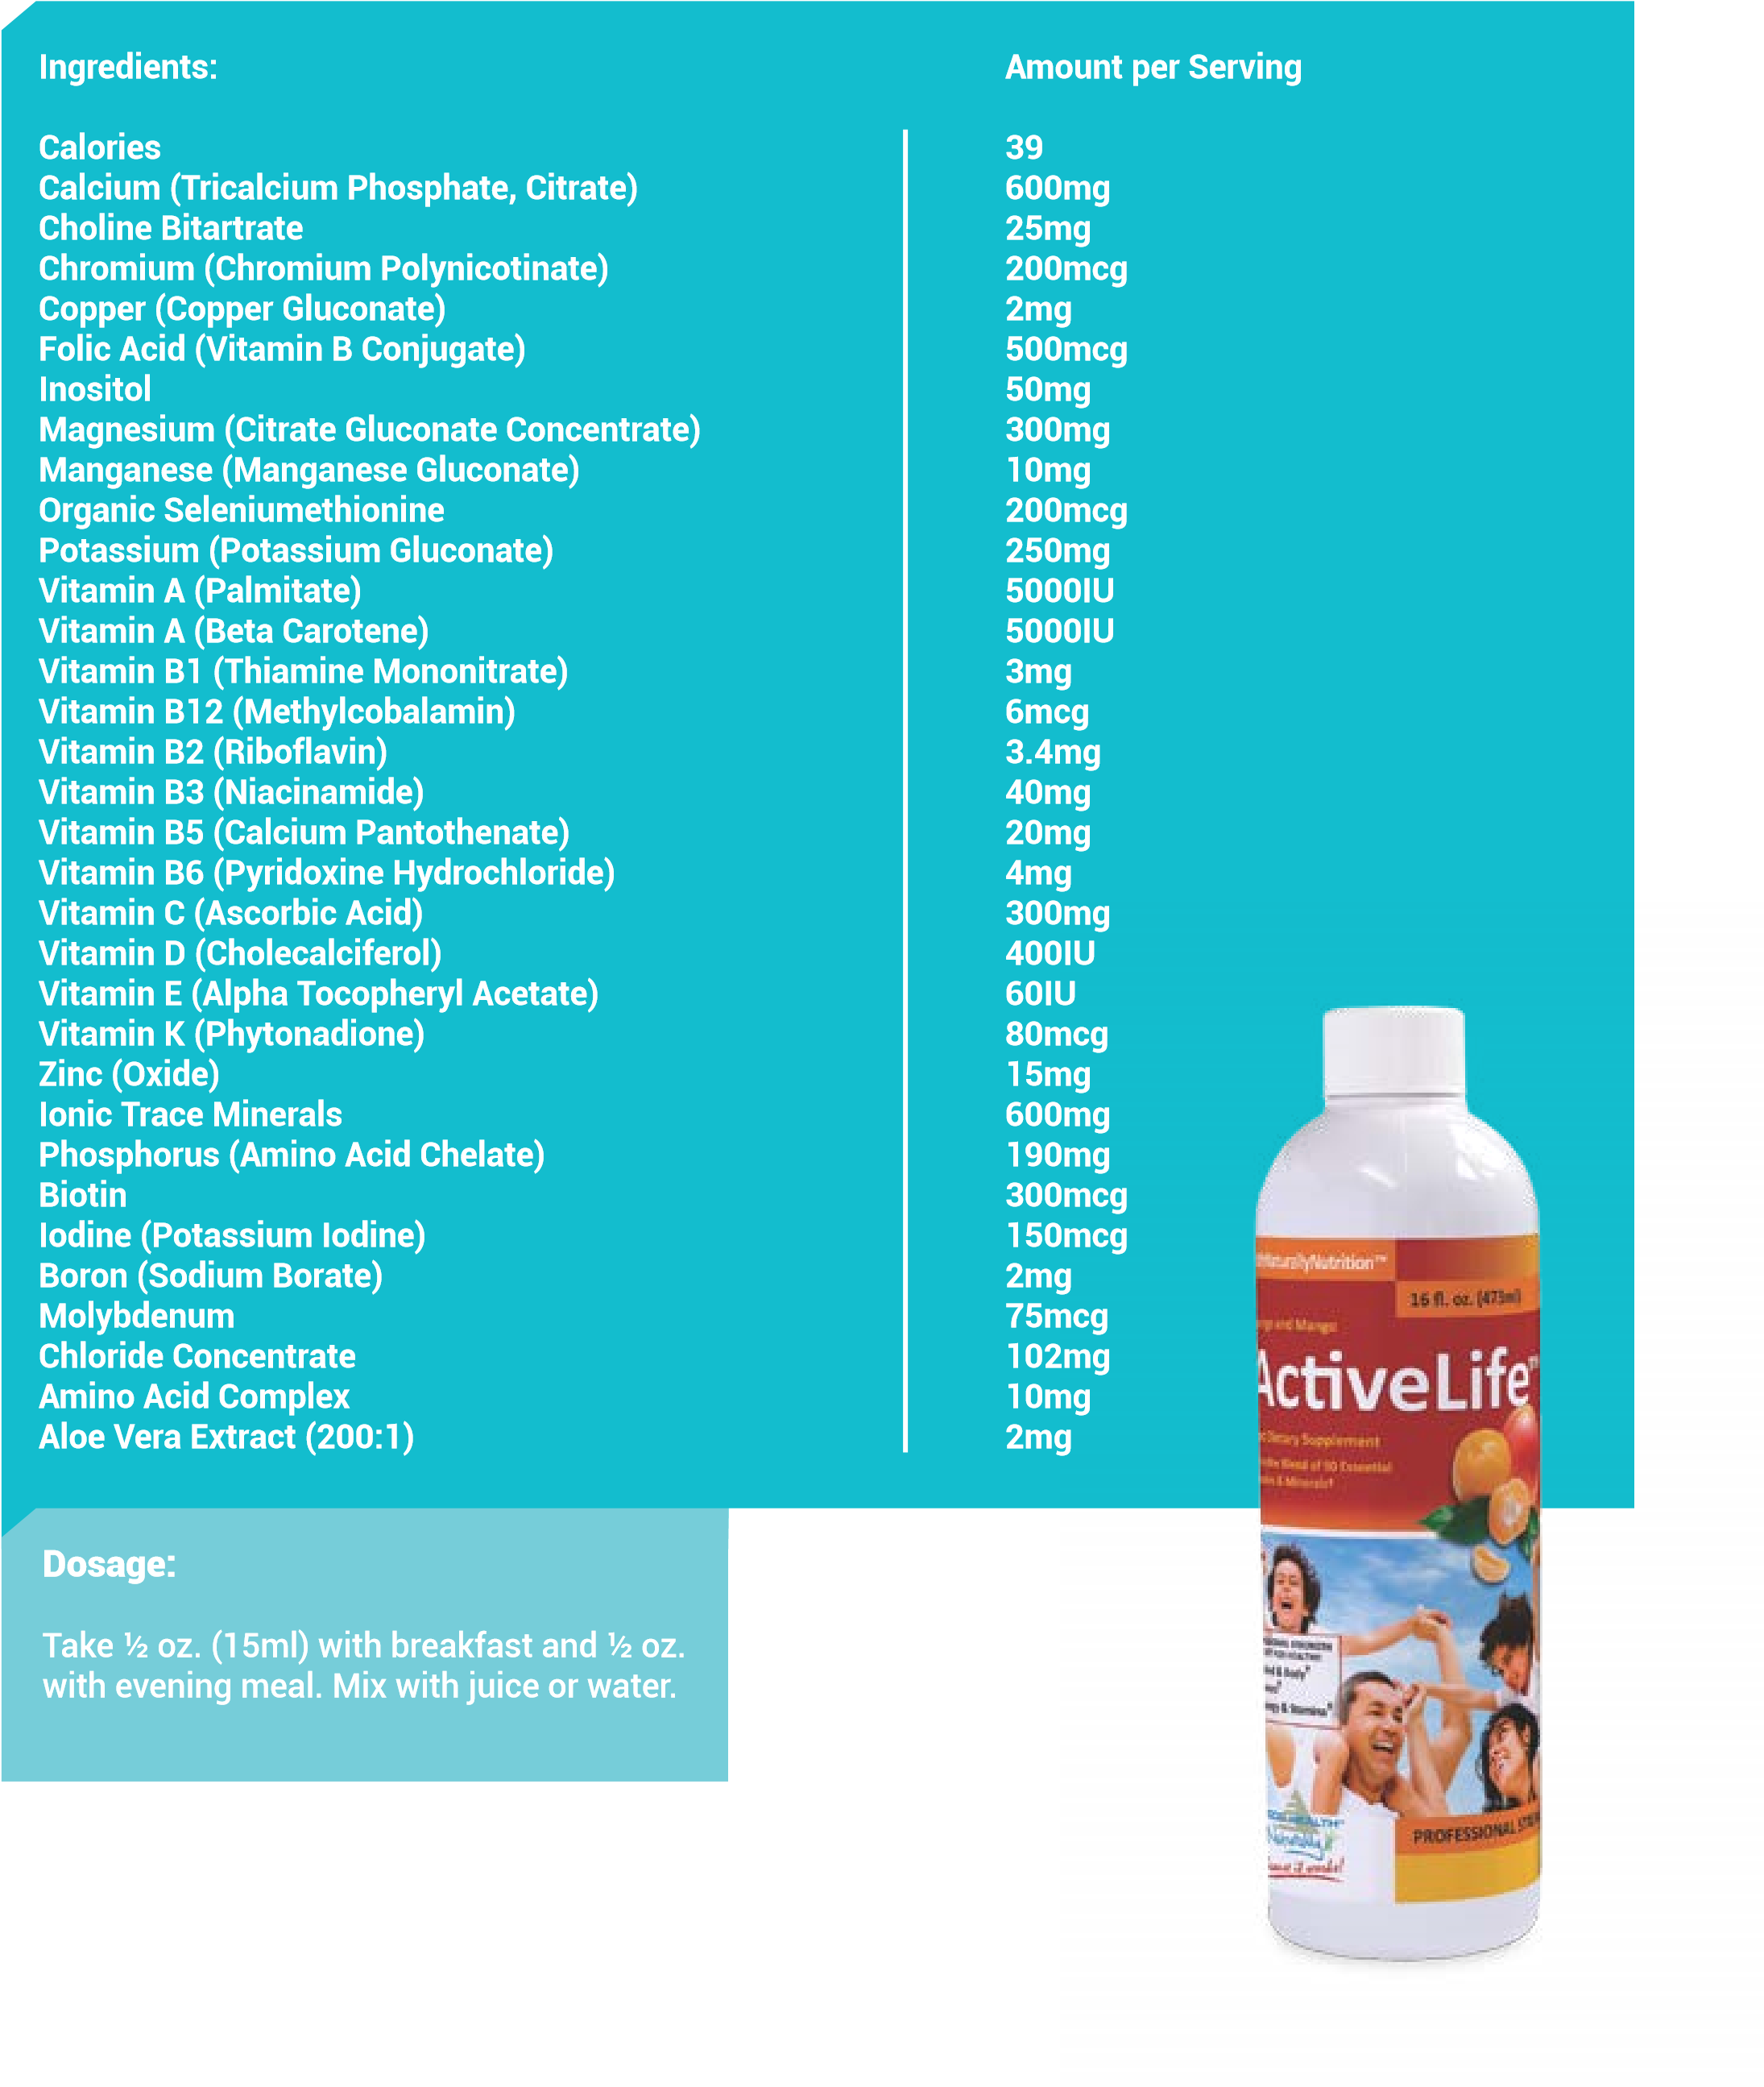

More About Optional Nutrients

UB8Q10 - Ubiquinol
CoQ10 or coenzyme Q10 is a greatly beneficial vitamin-like enzyme that is present in almost all plant, animal, and human cells. Coenzyme Q10 is considered as your body’s POWERHOUSE ENHANCER and ANTIOXIDANT. UB8Q10, also known as Ubiquinol, is a Coenzyme Q10 that is 8 times better absorbed compared to ordinary CoQ10!
The highest amounts of CoQ10 are found in your heart, kidneys, liver, and pancreas. However, although Coenzyme Q10 can be made in the body, the amount may not be enough, and deficiency can occur. The body might not be able to replenish the difference needed, as many people do not get enough of the vitamins and elements required to synthesize CoQ10 for optimal health. This means that

D-Ribose Plus™
D-Ribose Plus™ offers cellular energy that is critical for healthy recovery. D-Ribose (a 5-carbon sugar) is a critical part of ATP production; it is essential for cellular regeneration and cellular energy and can be deficient for many reasons. It has been found that when D-Ribose is combined with malic acid and magnesium, there is a synergy that results in greater noticeable energy.
Malic acid is both derived from food sources and synthesized in the body through the citric acid (Krebs) cycle. Its importance to the production of energy in the body during both aerobic and anaerobic conditions is wellestablished. Magnesium is a mineral that provides neverending benefits.
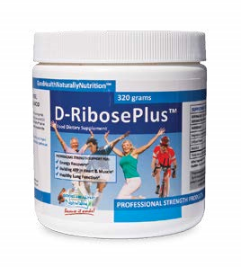
Ingredients:
Magnesium (from Magnesium Malate) – 60mg
D-Ribose Powder – 5000mg
Malic Acid – 240mg
Dosage:
5
teaspoons x 3 drops per day in water.

you may not be getting enough for your optimal health. And as you grow older, you are not replenishing the CoQ10
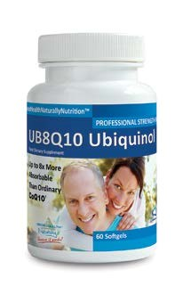
you need to carry on with your daily functions.
Ingredients:
Ubiquinol CoQH - 100mg
Dosage:
Take 2 capsules, 2 times a day for 1
month. Then take 1 capsule 2 times
a day forever.

RelaxWell™
RelaxWell™is a special formula created from tried and true quality ingredients known to support more restful and healthy sleep patterns. It utilizes a combination of B-vitamins to act as powerful aids against high stress and unwieldy cortisol levels.
RelaxWell™ combines L-Tryptophan, L-Theanine, Vitamin B6, and Vitamin B3 to make for a much better, rested YOU!
L-Tryptophan is an essential amino acid and the precursor to serotonin. Serotonin is a neurotransmitter responsible for transmitting nerve impulses in the brain, inducing sleep and tranquility, and stabilizing function of the central nervous system. Serotonin deficiencies, which are related to L-Tryptophan deficiencies, are well-documented in cases of depression and insomnia.
L-Theanine is a natural phytochemical found in Japanese green tea. L-Theanine is a non-essential amino acid that is present in the brain and is a close relative of Glutamate. Studies indicate that L-Theanine interacts with the neurotransmitter GABA (gamma-aminobutyrate). GABA, known for its importance in nervous system functioning, works with the mood centers of the brain.
RelaxWell™ - Suitable for Vegetarians and Vegans
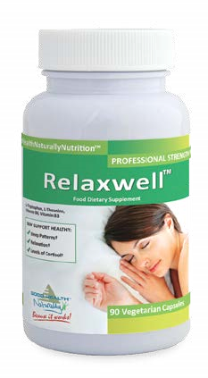
Active Ingredients:
L-TRYPTOPHAN - 500mg
L-THEANINE - 100mg
50
% of your daily value of VITAMIN B3 - NICOTINIC ACID - 10mg
50
% of your daily value of VITAMIN B3 - NIACINAMIDE - 10mg
500
% of your daily value of VITAMIN B6 - PYRIDOXINE HCI - 10mg
Other Ingredients:
Vegetable cellulose (capsule)
Rice bran
Medium chain triglycerides
Dosage:
Take 1 capsule, 3 times daily
Left blank intentionally for your notes.

Left blank intentionally for your notes.

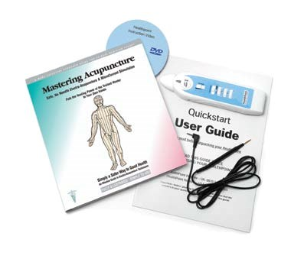
More About Acupressure
Stimulating the Cranial Electrotherapy Stimulation (CES) ear points for anxiety shown in the ear clip instructions and acu-points in page 8.14 to 8.15 of the book Mastering Acupuncture will help to balance your health. These points can be effectively and safely stimulated using the HealthPoint™ electro-acupressure kit. The advantage of the kit is that it gives you the power to precisely locate the acupuncture point, and indeed other points, so you can enjoy the benefits of acupuncture at home and without any needles.
HealthPoint™ is easy to use, painless, and effective. It includes an instructional DVD and book covering over 150 pain and non-pain conditions that can be helped, such as headaches, back, neck, and joint problems.
The gentle and systematic stimulation of the body’s natural healing system can speed recovery in many cases. HealthPoint™ breakthrough technology was developed by leading pain control specialist Dr. Julian Kenyon MD 21 years ago, and today features the latest microchip technology to quickly locate acupuncture points key to specific health conditions, such as the points for fibromyalgia.
Cranial Electrotherapy Stimulation and Fibromyalgia
Cranial electrotherapy stimulation (CES) is a well-documented neuro-electrical modality that has been proven effective in some good studies of fibromyalgia (FM) patients. CES is no panacea but, for some FM patients, the modality can be valuable.
Fibromyalgia frequently has many symptoms such as anxiety, depression, insomnia, and a great variety of different rheumatologic and neurological symptoms that often resemble multiple sclerosis, chronic fatigue syndrome, and others. Active self-involvement in care usually enhances the therapeutic results of various treatments and also improves the patient's sense of control over the condition.
A form of evoked potential biofeedback, HealthPoint™ offers a powerful stress reduction technique. It assesses the chief stressors and risk factors for illness that can impede the FM patient's built-in healing abilities. Future healthcare will likely expand the diagnostic criteria of FM and/or illuminate a group of related conditions and the ways in which these conditions relate to each other.
Support for fibromyalgia and related conditions increasingly involves multi-modality treatment that features CES as one significant part of the therapeutic regimen. This eBook also includes CES as an invaluable, cost-effective add-on to many therapies.
In Conclusion:
The Non-Inflammatory Lifestyle Program is a complete program, one designed to address all aspects of what is required to prevent or control your fibromyalgia.
Fibromyalgia is essentially a lifestyle disease, meaning if the lifestyle is changed, there is every likelihood of some recovery. With the changes in this 10 Step Plan put into effect, the body is perfectly capable of healing and recovering good health. Drugs don’t make you healthy.
Drugs do not work in that they do not make you healthy. At best, drugs will help you feel better; at worst, they will speed up degeneration and contribute to premature death.
The pharmaceutical business would prefer you continue your present, ineffective treatment plan, only utilizing toxic pills in the form of immune-suppressing drugs and avoiding the true path to prevention and healing.
You are now learning there is a better way.
The Non-Inflammatory Lifestyle Program is structured for those patients struggling to prevent or control their fibromyalgia, even after other medical treatments have failed:
- A program that can help you learn how to love your health and improve your quality of life. The NonInflammatory Lifestyle Program includes treatment in the form of exercise, education, and coaching.
- A personalized program that incorporates therapy and support, assisting the person in achieving the maximum results possible.
The Non-Inflammatory Lifestyle Program is detailed within this book and, when carefully followed, will show results within weeks.
You will always end up healthier with this plan.
The worst thing that can happen with this plan is that you will get healthier but still need to take drugs if they or the disease have damaged you to the extent that you are reliant on them.
Take it all slowly and step by step.
Unless you are already used to making changes in your life, you will find adopting these habits of healthy living can be difficult to sustain. Persist. Because…
Make no mistake...Your life is worth it.
Robert Redfern, Your Health Coach Email Robert@goodhealth.nu www.MyGoodHealthClub.com for step by step coaching and support.
Sample Daily Fibromyalgia Rehabilitation Plan
Time Action Amount

BREAKFAST
Before Breakfast |  | Serranol™ |  | Take 2 capsules
Breakfast |  | 1st Line Immune Support |  | Take 1 kit daily for 3 days
Breakfast |  | GlycoBoost |  | Take 2 teaspoons a day for 30-60 days
Breakfast |  | D-Ribose Plus™ |  | 5 teaspoons in a glass of water
Breakfast |  | RelaxWell™ |  | Take 1 capsule
Breakfast |  | Nascent Iodine Colloidal Drops |  | Take 3 drops in a glass of water

LUNCH
Before Lunch |  | Serranol™ |  | Take 2 capsules
Lunch |  | ActiveLife™ 90 Vitamins/Minerals |  | Take 15ml
Lunch |  | Prescript-Assist® |  | 1 capsule
Lunch |  | D-Ribose Plus™ |  | 5 teaspoons in a glass of water
Lunch |  | Ubiquinol |  | Take 2 capsules with food
Lunch |  | RelaxWell™ |  | 1 capsule
Lunch |  | Nascent Iodine Colloidal Drops |  | Take 3 drops, in a glass of water

EVENING MEAL
 | Before Dinner |  |  | Serranol™ |  |  | Take 2 capsules
Dinner  Dinner |  |  | ActiveLife™ 90 Vitamins/Minerals  D-Ribose Plus™ |  |  | Take 15ml
 |  |  |  |  |  | 5 teaspoons in a glass of water
Dinner  Dinner  Dinner |  |  | Ubiquinol  RelaxWell™  Nascent Iodine Colloidal Drops |  |  | Take 2 capsules with food
 |  |  |  |  |  | Take 1 capsule
 |  |  |  |  |  | Take 3 drops in a glass of water
All the books in this series:
- Acne, Eczema & Psoriasis
- Alzheimer’s & Senility
- Arthritis & Osteoporosis
- Cancer: Breast, Colon, Pancreatic & other cancers
- Cardiovascular Disease, PAD, Carotid & more
- Chronic Fatigue, Fibromyalgia & Candida
- Diabetes & Hypoglycaemia Cholesterol – Healthy Levels
- Electro Acupressure – Self-treatment of the Acu Points
- Fertility Problems
- Heart Disease, Angina, Valves & more
- High & Low Blood Pressure
- IBS, Crohn's, Colitis, Ulcers & other Digestive Problems
- Lung Disease, COPD, Emphysema & more
- Macular Degeneration, Cataracts & Diabetic Retinopathy
- Men: Prostate, EDF, & Hormones
- MS, RA, Lupus, Psoriatic Arthritis & other Auto Immune Diseases
- Stress & Anxiety
- Stroke Recovery & Prevention
- Women: PMS, Menopause, Fibroids, PCOs & Fibroids

Other Books by Robert Redfern
- The ‘Miracle Enzyme’ is Serrapeptase
- Turning A Blind Eye
- Mastering Acupuncture
- EquiHealth Equine acupressure

ABOUT THIS BOOK

My Good Health Club
Robert Redfern – Your Personal Health Coach www.MyGoodHealthClub.com
Robert Redfern is passionate about providing you with the right tools and information to help you become an expert in natural health so that you and your family can achieve great health. This book brings Robert’s research and work on fibromyalgia and chronic fatigue into an easy-to-follow Fibromyalgia Rehabilitation Plan that everyone can use for improved health.
To help you further, Naturally Healthy Publications has built a website for dedicated Good Health Coaching based on Robert’s books.
Visit www.MyGoodHealthClub.com today for more support for health problems related to:
- Rheumatoid Arthritis  - Psoriatic Arthritis  - Juvenile Arthritis  - Multiple Sclerosis  - Hashimoto's Thyroiditis | - Motor Neurones Disease  - Lyme disease  - Lupus  - And much more
We received a testimonial from a man who told us about his wife’s recovery from fibromyalgia by following Robert’s health plan:
"She has had fibromyalgia for about four years and because of it her blood pressure has been uncontrollable; it ranged from 175 to 195 over 135 to 145. Her pulse rate would go from 110 to around 200.
After two weeks of taking your supplements three times a day, it is now running 112 to 120 over 74 to 78 and the pulse rate is staying around 74 to 78. What a blessing that her fibromyalgia is a lot better, she is doing more and getting tired less."
Bobby L.

