Written by Fintan Duggan owner of www.lowercholesterolserrapeptase.com
Written as a heart attack survivor at age 45, (now 65) I wasn't happy to just taking the advice of my doctor because as far as I could tell heart disease was primarily caused by plaque build-up and inflammation.
I don't feel that statin drugs and heart tablets are enough to clean clogged arteries, my arteries were badly clogged 70% blockage in the left anterior artery. I decided to research which supplements are best to help with cleaning clogged arteries.
I discovered by my research that Serrapeptase and Nattokinase are two powerful enzymes when combined could be very effective in reducing arterial plaque.
I read the book “No more heart disease" by Doctor Louis Ignarro, in his book he talked a lot about how our bodies need to produce nitric oxide to keep our blood vessels clear and protect us against heart disease.
I also found out in my research that as you age your body doesn't create enough Nitric oxide naturally that is partly the reason that arteries become blocked.
The answer is l arginine, by taking more l arginine in powder form into your body blood vessels start to slowly unclog.
I began my own program to unclog my arteries over 18 months ago, to be honest it has worked very well for me, my energy levels have increased I feel much better.
If you are in the same situation as me if you have had a heart attack or your arteries are clogged then I recommend that you give my 12-month program a try, it will be effective providing you stick with it.
Note: i will make a small commission should you decide to go ahead and try the program, results will vary.
If you need any further assistance or have a question please let me know on fintanduggan@gmail.com
How to clean clogged arteries in 12 months program
Thank you for opening this document, the program is based on science, common sense and my own experience of unclogging my arteries following a massive heart attack in my mid-forties.
I use the exact same methods outlined on this page in conjunction with a heart healthy diet, regular exercise, I try to keep stress out of my life, I drink a couple of glasses of red wine at the weekends, even though I have a sweet tooth I try to stay away from foods that contain sugar.
I keep taking my statin drugs to keep my cholesterol under control, that works in conjunction with the natural products as part of the program.
The natural products that I recommend contain Serrapeptase and Nattokinase both of these enzymes are crucial to unclogging your arteries, they are well tolerated by most people, safe to take and the side effects are few for most but not for everyone.
The products also contain l arginine, it is critical that you take l arginine because it will help your body to produce more nitric oxide, nitric oxide works to get your arteries softer, softer arteries mean that blood flow will start to improve and that is the start of unclogging your arteries.
Products that you need for the 12-month program

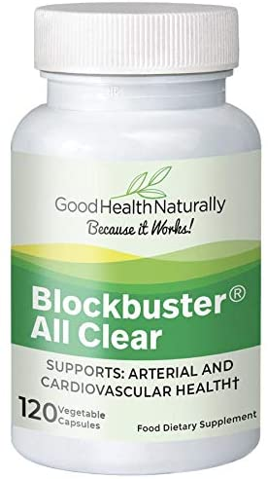
Blockbuster AllClear – formulated to provide a synergistic “all purpose” formula

Now in Delayed Release Capsules and 80,000iu Serrapeptase Per Serving!

. Description
• A powerful collection of enzymes and supporting nutrients geared up towards reducing inflammation, promoting healing and internal cleansing, blood pressure reduction, arterial cleansing and lung support to name just a few benefits.
• Serrapeptase – The Serrapeptase content per dose is 40,000IU to give a greater anti-inflammatory effect while clearing inflamed dead tissue.
• Grapeseed Extract – A concentrated source of oligomeric proanthocyanidins (OPC). These anti-oxidants help protect cells from free radical damage and also promote healthy circulation.
• Pycnogenol – One of the most powerful supplements with a history of well-documented research. Pycnogenol is known to help lower blood pressure. It is made from the bark of a white pine and contains powerful antioxidants useful for the strengthening of blood capillaries. Research confirms that Pycnogenol is 50 times more powerful than Vitamin E in its antioxidant properties and 20 times more powerful than Vitamin C. Pycnogenol in particular has been found to be exceptionally useful for fighting against capillary fragility and varicose veins, diabetic retinopathy, swollen legs and other inflammatory conditions in veins and capillaries.
• Vitamin K2 – (as menaquinone-7), studies have shown this helps clear blockages in the arteries and prevent bone degeneration.
• Policosanol – Research has shown Policosanol helps to lower cholesterol in the body reducing cholesterol levels by a complex mechanism. It reduces your total cholesterol mainly by reducing your LDL-cholesterol (bad), which is the dominant kind in your bloodstream. At the same time, however it increases your HDL-cholesterol (good), which exists in smaller amounts. It also reduces your triglycerides (fats).
• Blockbuster AllClear helps to support:
o Arteries and Cardiovascular System
o Blood Pressure and Circulatory System
o Lungs and Bronchial System
o Digestive System
o Autoimmune System
o Joints and Connective Tissue
o Eyes and Brain

Key Ingredients:
Contains: Rice bran, Hydroxypropylmethylcellulose enteric coated Serrapeptase, Cellulose and Water (vegetable capsule).
Contains Nattokinase extracted from Soy.
Suitable for Vegetarians.
Amount Per Serving Information
Serrapeptase 40,000 IU
Nattokinase 1600 FU
Protease 20,000 HUT
Lipase 1000 LU
Amylase 4000 SKB
Cellulase 600CU
Lactase 1000 ALU
Acerola 17.5% 50 mg
amla 45% Tannins 50 mg
Olive Leaf Citrus Blend Citrolive™ 225 mg
Trace Mineral Complex (Coral Calcium) 100 mg
Lactospore Probiotics 15 million 25 mg
Protease S 5 mg
Grapeseed Extract 25% 100 mg
Policosanol 6 mg
Pycnogenol® 10 mg

Recommended Usage:
Take 2 capsules twice daily 30 minutes before food

Contra-indications:
Blockbuster AllClear contains ingredients that may dissolve blood clots. This is normally beneficial, but in certain conditions may be harmful.
This product should not be taken if you suffer from: A blood disorder that affects the ability of the blood to clot e.g. Haemophilia.
A stroke which has resulted in inter cranial bleeding in the last 6 months.
Haemorrhoids (piles). Recent surgery or trauma
To purchase Blockbuster AllClear, go to Good Health Naturally by clicking here.
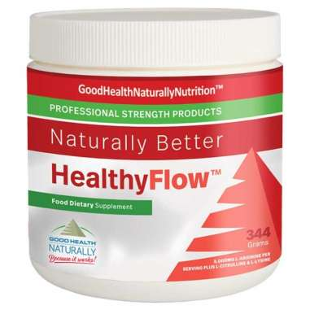
Healthy Flow™ Powder

Natural Support for Normal Healthy Blood Flow
HealthyFlow™ is one of the most important essential amino acid formulas for circulatory support. All systems are affected and improved by healthy blood flow, from digestive support to normal brain health.

Now with AstraGin™ For Improved Nutrient Absorption
AstraGin™ is a proprietary formulation consisting of ginsenosides extracted from Panax notoginseng and alcohol fraction from Astragalus membranaceous. AstraGin™ has been demonstrated in humans to significantly promote and improve absorption of amino acids, glucose, and vitamins.

Contains A Nitric Oxide Precursor
L-Arginine is a precursor in the formation of Nitric Oxide, creatine, polyamines, L-glutamate, l-proline, agmatin (a possible neurotransmitter in the brain) andTtetrapeptide tuftsin, believed to be an immunomodulatory.

Essential Amino Acids
L-Arginine is a protein amino acid present in the proteins of all life forms. It is classified as a semi-essential or conditionally essential amino acid.

Suitable for Vegetarians and Vegans
Serving Size
1 scoop (11.46gms) or 1 Tablespoon
Servings Per Container
30

Directions
1 scoop daily mixed with water
Name | Amount Per Serving | % DV
L-Arginine | 5000mg | ♦
L-Lysine | 1,500mg | ♦
L-Citrulline | 200mg | ♦
Grapeseed Extract 95% | 150mg | ♦
AstraGin™ (contains astraglaus membrenaceus and panax notoginseng) | 50mg | ♦
Grape Skin Extract 4:1 (Polyphenols) | 25mg | ♦
Proprietary Blend  - Citric Acid  - Be Flora  - Potassium Sorbate  - Silica | 3840mg | ♦
♦ = Daily Value not established

Other Ingredients
- Natural flavouring
- Stevia Extract 200:
To purchase Healthyflow TM go to Good health Naturally here

